## Mystery of Khaman Temple

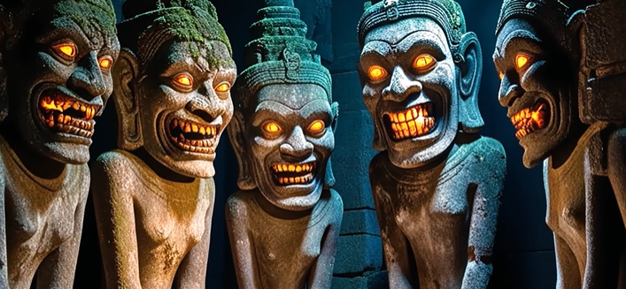

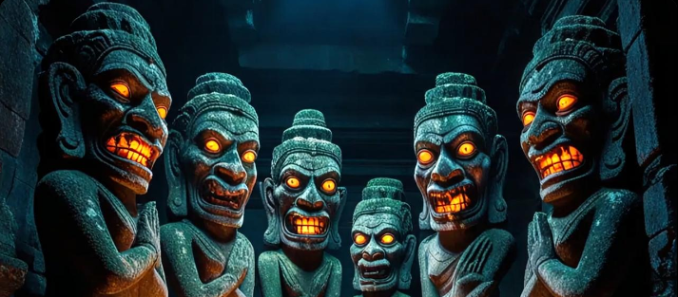

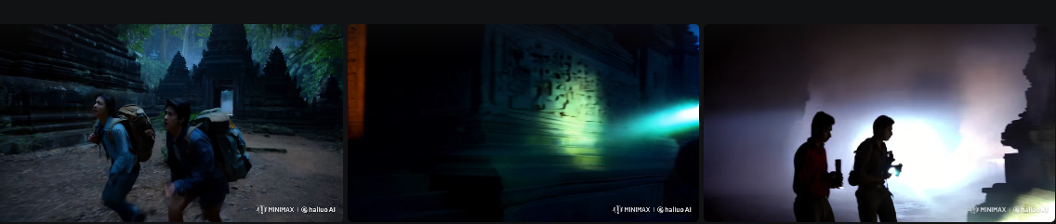

**AI Filmmaking: Processes and Tools**

**Process 1: Script Generation**

In the first phase of AI filmmaking, we used ChatGPT, a powerful language model developed by OpenAI, to generate the script. ChatGPT excels in producing coherent and creative narratives by interpreting user inputs and delivering contextually relevant outputs.

**How GPT Helps in AI Video Making**

ChatGPT allows creators to generate storylines, dialogues, and concepts quickly, adapting to various genres. Its flexibility supports brainstorming and refining ideas, making it invaluable for the creative aspects of filmmaking.

**Chosen Genre: Ancient**

We focused on the "Ancient" genre, crafting a story rich in historical themes and settings. ChatGPT generated a vivid and immersive script, providing detailed dialogues and descriptions tailored to the era.

**Prompt Enhancement with Gravity**

To refine the prompts for more precise and contextually rich outputs, we utilized Gravity. This tool helped us direct ChatGPT towards a highly detailed and engaging narrative, ensuring the storyline met our expectations.

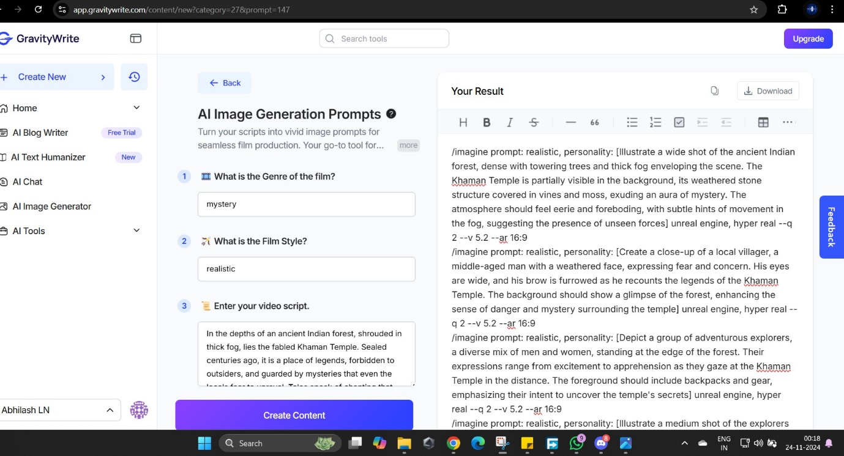

**Process 2: Image and Scene Generation**

For the second process, we leveraged various AI tools to create visuals and synchronize audio, crafting compelling scenes:

**Scene Generation Tools**

* **Leonardo AI**: Generated high-quality images to match the ancient theme of the script.
* **Runway ML**: Provided motion-based scene development, allowing dynamic and visually appealing sequences.
* **Bool Video**: Assisted in creating video scenes, ensuring smooth transitions and thematic consistency.

**Voice and Lip Sync**

* **Lipsync AI**: Integrated realistic lip movements with the script's dialogues, ensuring perfect synchronization.
* **Eleven Labs IO**: Converted the script text into lifelike voiceovers, adding depth and emotion to the characters.

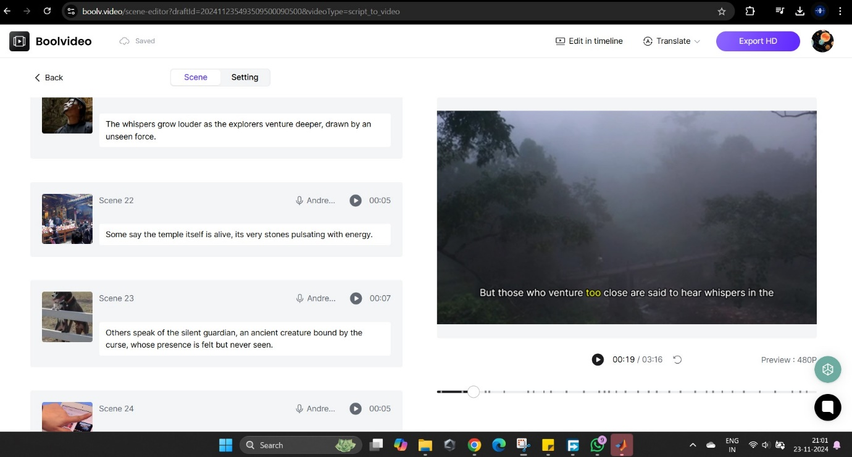

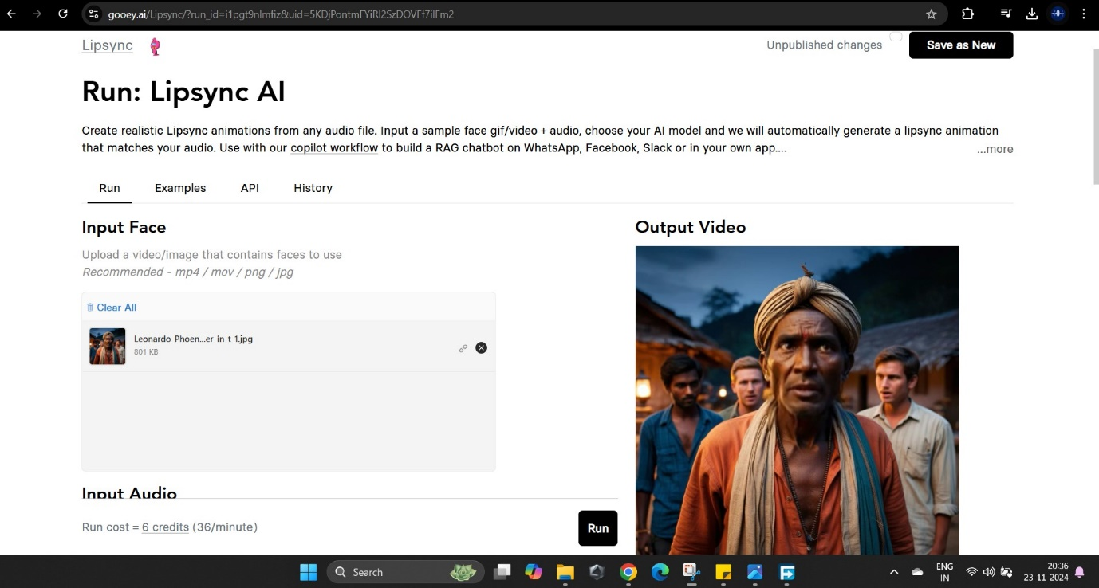

These tools collectively brought the script to life with visually stunning scenes and realistic voice integration.



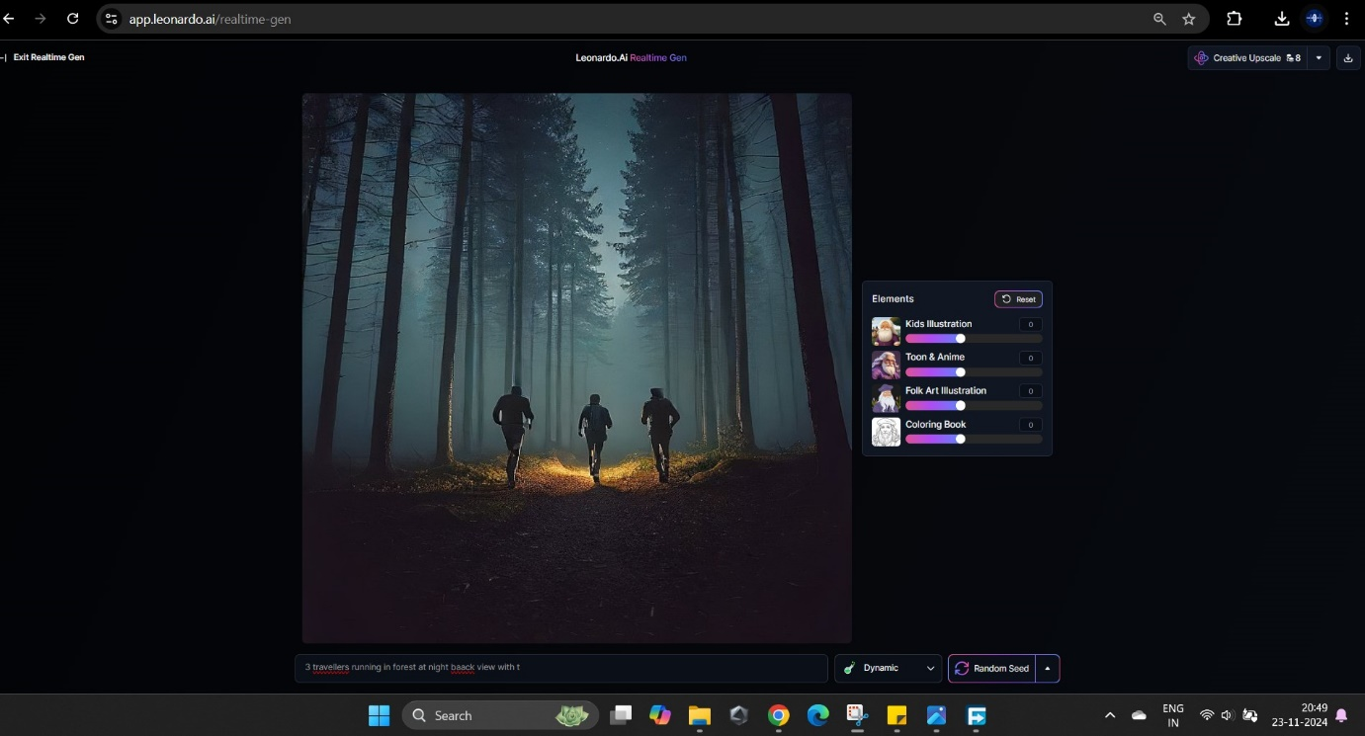

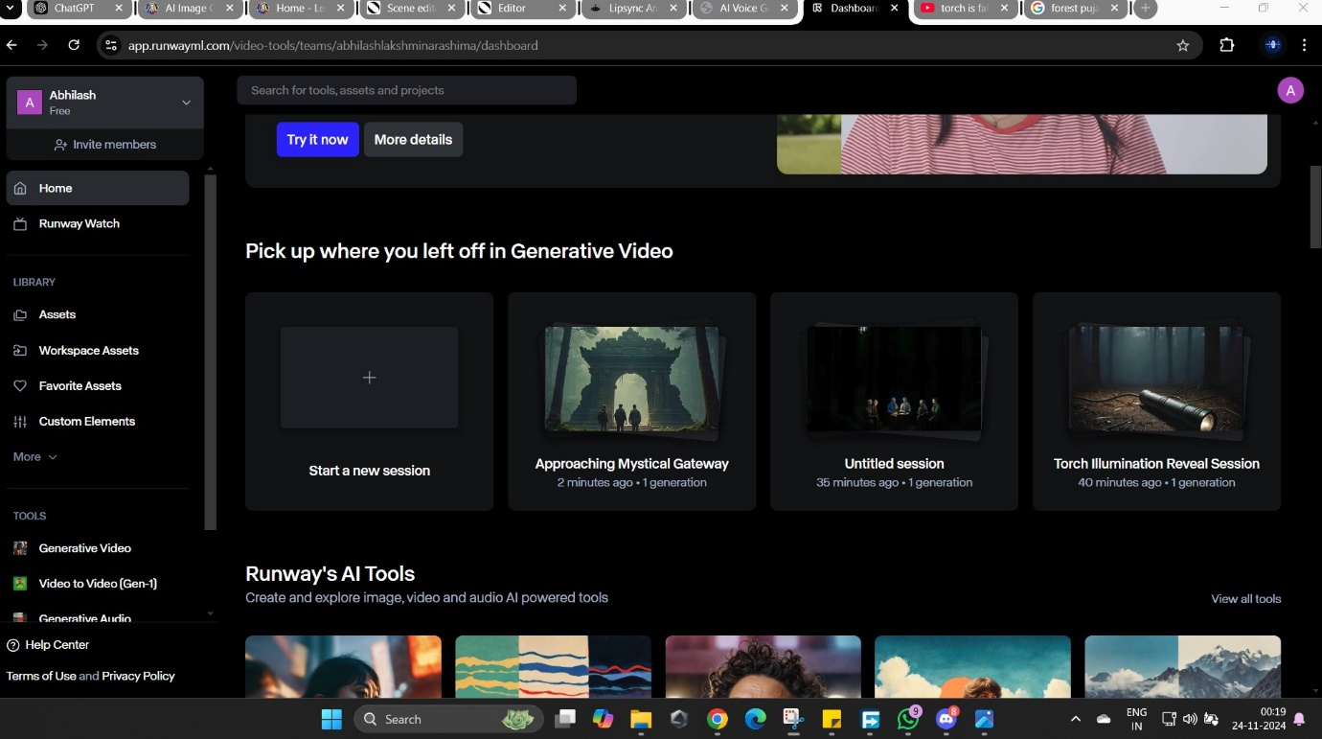

**Process 3: Combining Scenes**

In the final phase, we used **Filmora** to compile the generated scenes. Filmora’s intuitive interface enabled us to blend visuals and audio seamlessly. Transitions, effects, and final touches were added here to produce a polished and cohesive video.

